Figure 1: Database Initialization Script Execution (db_init_2022.sql)
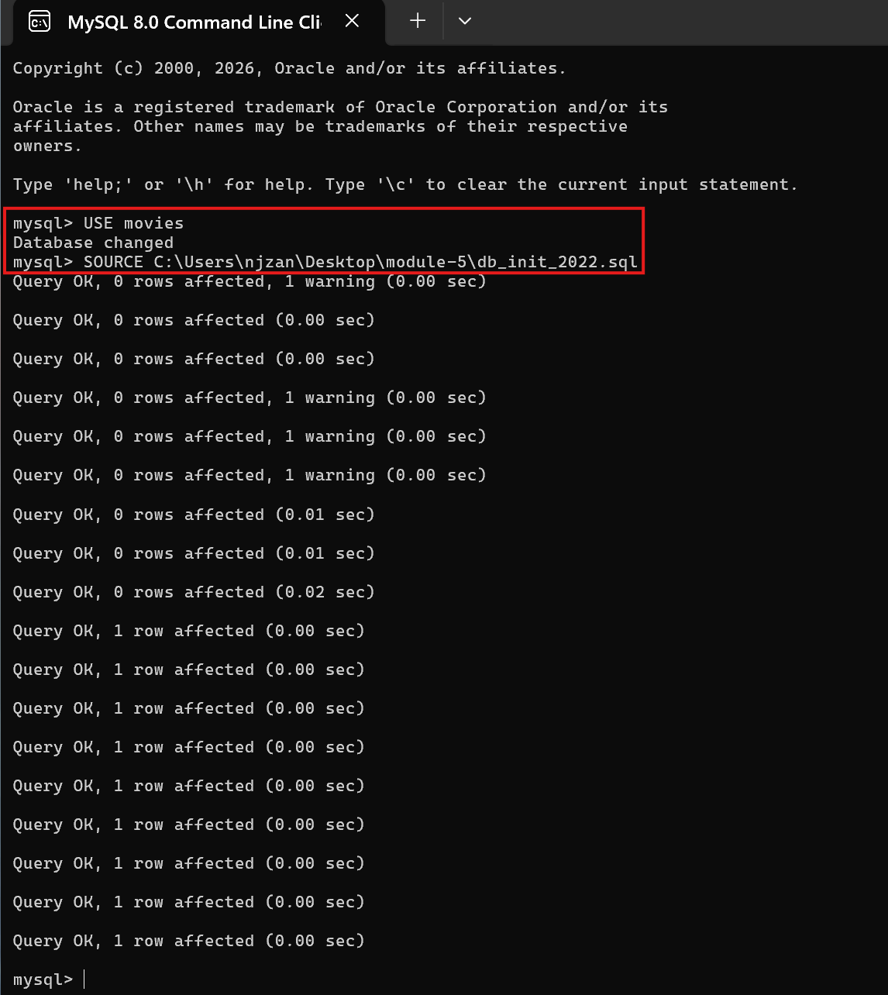
Description: Terminal output showing the successful execution of the db_init_2022.sql script to create database users, grant privileges, and construct tables.
Figure 2: Verification of Database Tables (SHOW TABLES;)
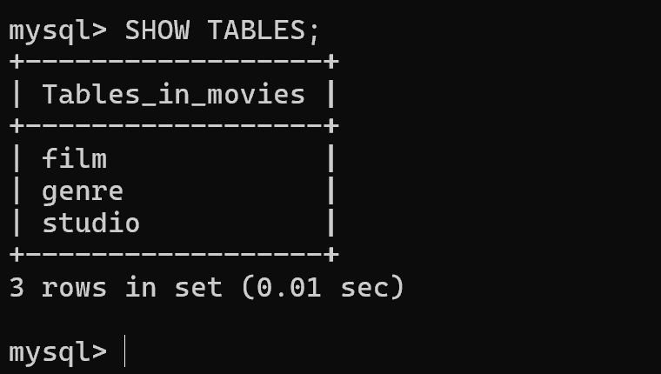
Description: Results of the SHOW TABLES; command confirming all required tables were created inside the movies database.
Figure 3: Python Connection Test (mysql_test.py)
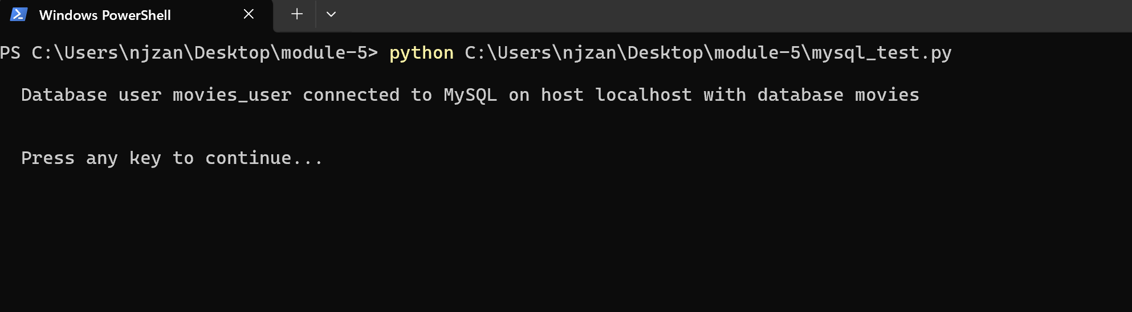
Description: Successful execution of mysql_test.py demonstrating a secure connection to MySQL using credentials stored in the .env file.

